The JSON file is an exam with 4 sections and looks like this when opened up in Firefox:

Each of the sections has between 22 – 28 questions and I would like you to extract the text data of the questions from each section and make each of the sections into a separate word doc.

This is what the first section looks like when opened up (I’ve opened up the ‘items’ section):

The text of the questions and answers is in each one of the ‘item’ sections. Here I’ve opened up the first two questions and below the image is what I want the text to look like in the word doc.

A company employee generates a series of five-digit product codes in accordance with the following rules:

The codes use the digits 0, 1, 2, 3, and 4, and no others.

Each digit occurs exactly once in any code.

The second digit has a value exactly twice that of the first digit.

The value of the third digit is less than the value of the fifth digit.

1. If the last digit of an acceptable product code is 1, it must be true that the

A - first digit is 2

B - second digit is 0

C - third digit is 3

D - fourth digit is 4

E - fourth digit is 0

1. Which one of the following must be true about any acceptable product code?

A - The digit 1 appears in some position before the digit 2.

B - The digit 1 appears in some position before the digit 3.

C - The digit 2 appears in some position before the digit 3.

D - The digit 3 appears in some position before the digit 0.

E - The digit 4 appears in some position before the digit 3.

The ‘stimulusText’ is the first thing and the question is item 0, with the ‘stemText’ being the question itself and the ‘options’ being the answer choices. You would label each question with the number that is the ‘itemPosition’ and the answer choice with the letter that is the ‘optionLetter’. The ‘items’ won’t all have the same ‘stimulusText’, they will be grouped in terms of 5, 6, or 7 (it varies) with the same ‘stimulusText’. If questions don’t have the same ‘stimulusText’ then don’t copy it.

The second section is similarly structured but here the ‘stimulusText’ is always different so you should copy it for every question. Here’s what the JSON looks like and how I would like it to be formatted is below:

Every business strives to increase its productivity, for this increases profits for the owners and the likelihood that the business will survive. But not all efforts to increase productivity are beneficial to the business as a whole. Often, attempts to increase productivity decrease the number of employees, which clearly harms the dismissed employees as well as the sense of security of the retained employees.

1. Which one of the following most accurately expresses the main conclusion of the economist's argument?

A - If an action taken to secure the survival of a business fails to enhance the welfare of the business's employees, that action cannot be good for the business as a whole.

B - Some measures taken by a business to increase productivity fail to be beneficial to the business as a whole.

C - Only if the employees of a business are also its owners will the interests of the employees and owners coincide, enabling measures that will be beneficial to the business as a whole.

D - There is no business that does not make efforts to increase its productivity.

E - Decreasing the number of employees in a business undermines the sense of security of retained employees.

The second section is the same but the third is different. Here, the ‘stimulusText’ is very large and is a passage that is followed by 6-7 questions. Only repeat the stimulus text for the relevant questions:

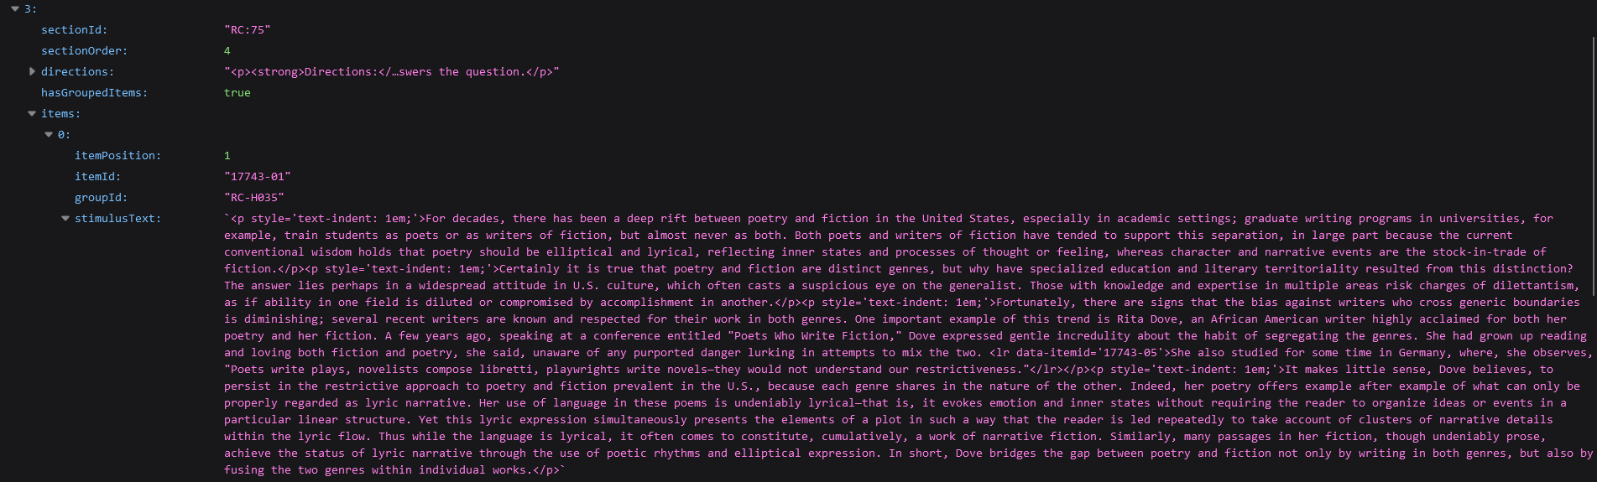

For decades, there has been a deep rift between poetry and fiction in the United States, especially in academic settings; graduate writing programs in universities, for example, train students as poets or as writers of fiction, but almost never as both. Both poets and writers of fiction have tended to support this separation, in large part because the current conventional wisdom holds that poetry should be elliptical and lyrical, reflecting inner states and processes of thought or feeling, whereas character and narrative events are the stock-in-trade of fiction.

Certainly it is true that poetry and fiction are distinct genres, but why have specialized education and literary territoriality resulted from this distinction? The answer lies perhaps in a widespread attitude in U.S. culture, which often casts a suspicious eye on the generalist. Those with knowledge and expertise in multiple areas risk charges of dilettantism, as if ability in one field is diluted or compromised by accomplishment in another.

Fortunately, there are signs that the bias against writers who cross generic boundaries is diminishing; several recent writers are known and respected for their work in both genres. One important example of this trend is Rita Dove, an African American writer highly acclaimed for both her poetry and her fiction. A few years ago, speaking at a conference entitled "Poets Who Write Fiction," Dove expressed gentle incredulity about the habit of segregating the genres. She had grown up reading and loving both fiction and poetry, she said, unaware of any purported danger lurking in attempts to mix the two. She also studied for some time in Germany, where, she observes, "Poets write plays, novelists compose libretti, playwrights write novels—they would not understand our restrictiveness."

It makes little sense, Dove believes, to persist in the restrictive approach to poetry and fiction prevalent in the U.S., because each genre shares in the nature of the other. Indeed, her poetry offers example after example of what can only be properly regarded as lyric narrative. Her use of language in these poems is undeniably lyrical—that is, it evokes emotion and inner states without requiring the reader to organize ideas or events in a particular linear structure. Yet this lyric expression simultaneously presents the elements of a plot in such a way that the reader is led repeatedly to take account of clusters of narrative details within the lyric flow. Thus while the language is lyrical, it often comes to constitute, cumulatively, a work of narrative fiction. Similarly, many passages in her fiction, though undeniably prose, achieve the status of lyric narrative through the use of poetic rhythms and elliptical expression. In short, Dove bridges the gap between poetry and fiction not only by writing in both genres, but also by fusing the two genres within individual works.

1. Which one of the following most accurately expresses the main point of the passage?

A - Rita Dove's work has been widely acclaimed primarily because of the lyrical elements she has introduced into her fiction.

B - Rita Dove's lyric narratives present clusters of narrative detail in order to create a cumulative narrative without requiring the reader to interpret it in a linear manner.

C - Working against a bias that has long been dominant in the U.S., recent writers like Rita Dove have shown that the lyrical use of language can effectively enhance narrative fiction.

D - Unlike many of her U.S. contemporaries, Rita Dove writes without relying on the traditional techniques associated with poetry and fiction.

E - Rita Dove's successful blending of poetry and fiction exemplifies the recent trend away from the rigid separation of the two genres that has long been prevalent in the U.S.